STACJONARNA OBRACARKA PALET
TOPPY L-SHAPE
Galeria zdjęć:

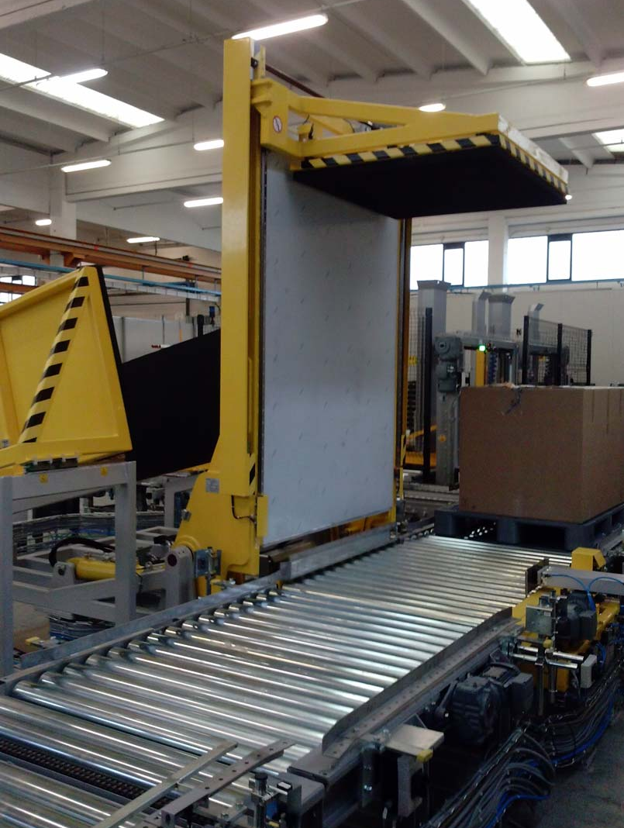

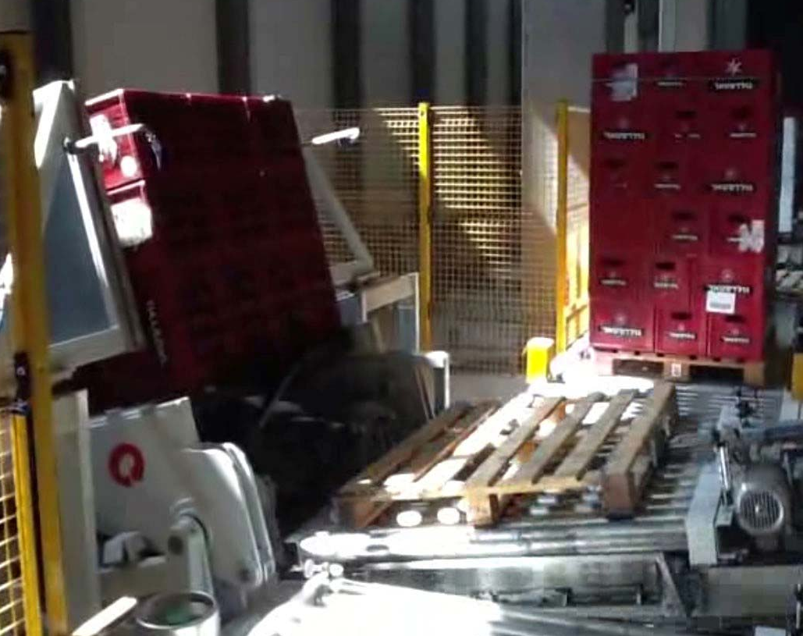
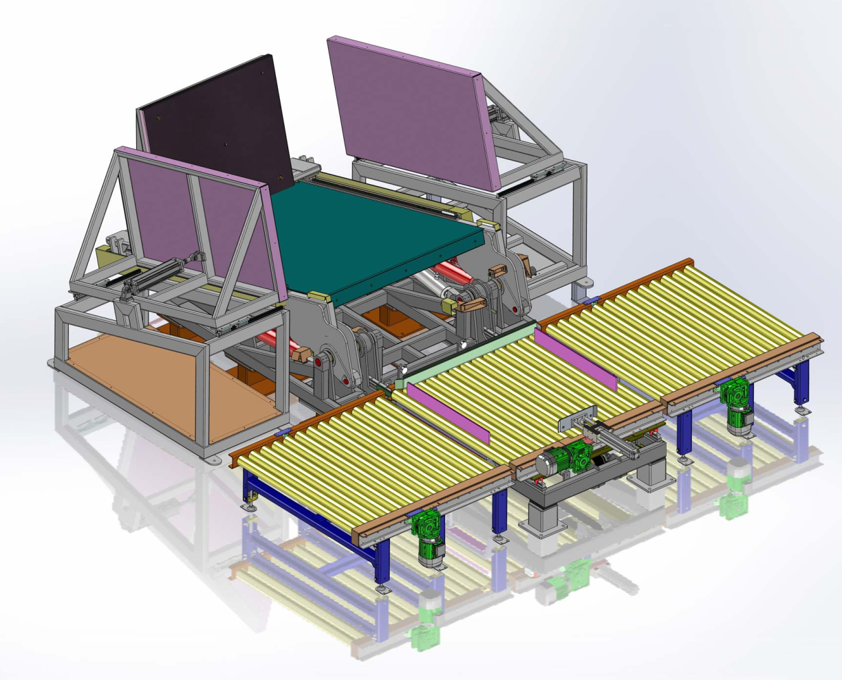

Film:
https://www.youtube.com/watch?v=N0Gb8plZK3o&feature=share&list=PL59qGZfTYORmFpmhPEXqrbHS9tpcOlMWD&index=2

Opis:
Toppy L-shape stationary pallet changer is integrated with logistic lines. The pallet changer is fully automatic and allows a very quick pallet changing process.

